**Bug Report**

**Product Name:** GENEO Software Website

**Product Version:** n/a

**Bug Name:** Hyperlink For 5 Guiding Principles Under Go Look See Page Not Available.

**Bug ID:** 0001

**Bug Status:** New

**Page Url:** <https://www.geneo.co.uk/blog/5-guiding-principles/>

**OS:** Windows 10

**Area Path:** Home Page >> Blog >> 5 Guiding Principles>> Go Look See

**Severity:** Low

**Priority:** Low

**Assigned to:** Frontend Developer

**Reported By:** Peter Abah

**Reported On:** 3rd June 2021.

**Reason:** This bug may hinder users from navigating the other points (Respect Our People, Teamwork, and Continuous Improvement) from the Go Look See Page.

**Status:** Open

**Environment:** Windows Laptop

**Description:** When a user, is on the Go Look See page of the Blog Topic, 5 Guiding Principles, they are unable to click on the last 3 points (Respect Our People, Teamwork, and Continuous Improvement) displayed on the page, as it is clickable on the other pages.

**Steps to Reproduce the Bug:**

* Open url <https://www.geneo.co.uk/>
* Click on Blog
* Click on 5 Guiding Principles Blog Post
* Scroll down to the bottom of the post.
* Click on Go Look See link.
* Scroll to the bottom of the post.
* Click on:
  + Respect Our People,
  + Teamwork, and
  + Continuous Improvement

Attached is a screenshot of the error after the above procedure.

**Expected Result:** On clicking Respect Our People, Teamwork, and Continuous Improvement points on the Go Look See Page, you are meant to be redirected to the pages hosting those posts.

**Actual Result:** The points are not clickable.

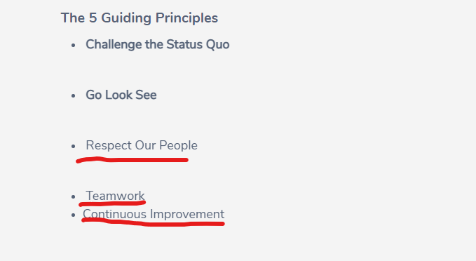

**Product Name:** GENEO Software Website

**Product Version:** n/a

**Bug Name:** Search Bar Retain Initial Search. (This may be an Out of Scope case)

**Bug ID:** 0002

**Bug Status:** New

**Page Url:** [https://www.geneo.co.uk](https://www.geneo.co.uk/blog/5-guiding-principles/)

**OS:** Windows 10

**Area Path:** Home Page >> Search Icon

**Severity:** Low

**Priority:** Low

**Assigned to:** Frontend Developer

**Reported By:** Peter Abah

**Reported On:** 3rd June 2021.

**Reason:** This bug may confuse users who expect the search bar to be cleared for a new search to be imputed.

**Status:** Open

**Environment:** Windows Laptop

**Description:** When a user clicks on the search icon and the search bar pops open with the initial word the user typed in, the user might get frustrated to have to clear up the search bar before entering a new search.

**Steps to Reproduce the Bug:**

* Open url <https://www.geneo.co.uk/>
* Click on the search icon
* Type in Software
* Allow the site to load
* Click on the search icon again after the load.

**Expected Result:** On clicking the search icon the second time after an initial search, the search bar is meant to be empty (might be out of scope)

**Actual Result:** The search bar shows the initial search keyword.

**Load Testing Report**

I ran load testing on the sites header pages and here are the results below, the test was run with 1000 users every 5 secs and the results shows that the site could not handle that load at the time and errors are also highlighted in the report.

